**Portfolio Part One (UFCFJL-30-1)**

**Student Name: Jamie Serlin**

**Student Number: 24030960**

**Guidance: This is the template that MUST be used for portfolio part one. The final version should be exported to pdf format and submitted via Blackboard. Please follow the instructions below and stay within the estimated page guidelines. Quantity does not equal quality or additional marks! You are welcome to adapt this template, including aesthetically, any way you see fit. If you have any questions or accessibility requirements please let the module team know.**

# **Glossary**

* Add each new term you discover throughout the module along with a definition.
* Higher grades will be awarded for students who also include a reference/citation to the location of the definition.
* **Estimated 1-2 pages**

|  |  |
| --- | --- |
| Normal | The direction that a face is facing on a mesh, perpendicular to the tangent |
| Subsurface scattering | A graphical technique that approximates light passing through a translucent surface such as hands or leaves |
| UV Unwrapping | The process of folding out a 3D model to allow textures to be applied |
| PBR | Physically Based Rendering is a rendering technique that uses additional textures for effects such as roughness, metalness, and extra normal detail with normal maps |
| High Concept | A short summary of the main design features and ideas of a game. |
| Vertex | A single point in the world, with x,y,z coordinates (and extra data for UV mapping). It is used in 3D modelling as they can be connected with edges and faces to create a mesh. |
| Linked List | A data structure in which multiple elements contain a reference to the next item of the list. This makes it easy to insert and delete elements. |
| Big O Notation | A mathematical concept to describe how fast different sorting algorithms work depending on the size of the set. |
|  |  |
|  |  |

# **Task 1: Tools and Techniques**

Choose **three** game engines to compare in the table below. Include the following:

* Pros – Advantages of the engine
* Cons – Disadvantages of the engine
* Appropriate Usage – Situations/projects where this engine would be most appropriate to use

Higher marks will be awarded for students who look beyond materials taught in class.

* **Estimated 1-2 pages**

|  |  |  |  |
| --- | --- | --- | --- |
| **Game Engine** | **Pros** | **Cons** | **Appropriate Usage** |
| Unity | -Easy to understand the interface and get started  -Many packages and in-built components  -Probuilder tool lets you create map blockouts in engine very quickly  -You can make your own in-editor tools using C# and Unity’s API  -Works very well in both 2D and 3D | -Can have a lot of slowdown when projects get large  -Not many high-quality assets on the asset store | -Great for coding experiments, as well as indie games.  -However, it is not well suited to large or AAA games as it lacks robustness. |
| Unreal Engine 5 | -Extremely powerful graphics engine, with tools such as nanite and lumen for real-time global illumination.  -Blueprint nodes let you script gameplay without needing to learn a language such as C++  - Quixel Megascans provides a huge library of high quality photoscanned assets to use for free in the engine. | - Quite demanding on performance, meaning you could be cutting out a large part of your playerbase  -Not very good at making 2D games as it was designed primarily for 3D. | Unreal can be used for just about anything, with many large AAA titles being on this engine (Fortnite, Silent Hill 2), as well as smaller indie games (Grey Zone Warfare, Hi-Fi Rush).  -Can also be used for films, architecture visualization and much more. |
| GameMaker 2 | - Specifically tailored to 2D games, so has lots of support for things like tilemaps and spritesheets.  - Very fast opening and build times, meaning it is quick to iterate on code.  - Simple and intuitive interface | - Custom scripting language means that there is not a lot of outside libraries, and you will need to write a lot of your own methods.  - No native video-playing support  - £300 to buy, whereas other engines are free to use. | - Great for any 2D games  - Good for beginner devs, especially those new to coding |

# **Task 2: Algorithms**

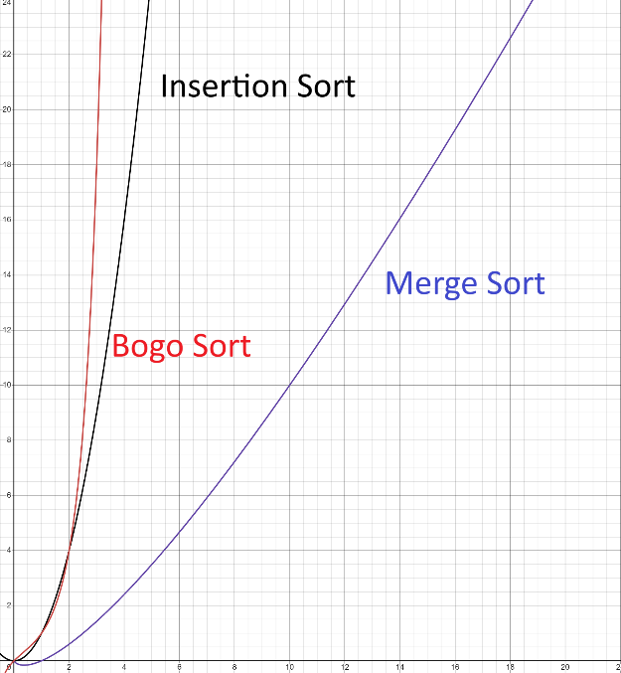Fill in the Big O Complexity Chart Below:

Operations

Elements

Choose **three** sorting algorithms and list their best case and worst case complexity in the table below:

|  |  |  |
| --- | --- | --- |
| **Sorting Algorithm** | **Best Case Complexity** | **Worst Case Complexity** |
| Insertion Sort | O(n) | O(n2) |
| Merge Sort | O(n log(n)) | O(n log(n)) |
| Bogo Sort | O(n) | O(1) |

* **Estimated 1-2 pages.**

# **Task 3: Data Structures**

## From the provided flow chart below, define the following data structures, and give an example of what would be an appropriate use:

## 2 Primitive data structures

## 2 Non-primitive linear data structures

## 1 Non-primitive non-linear data structures

## 

* **Estimated 1-2 pages.**

